**Project 13：Passive Buzzer**

1. **Introduction**

In this project, we will learn the passive buzzer and use the Plus control board to control the passive buzzer to play a song. Unlike an active buzzer, a passive buzzer can emit sounds of different frequencies.

1. **Components Required**

|  |  |  |  |
| --- | --- | --- | --- |
| 17a6d7f241a04d4e932cb06b758197c4 | | _DSC2552 | |
| Raspberry Pi Pico\*1 | | Raspberry Pi Pico Expansion Board\*1 | |
| H4QG0GNSDN2S4]TSS)6UP4J |  |  |  |
| Passive Buzzer\*1 | Breadboard\*1 | Jumper Wires | USB Cable\*1 |

**3. Component Knowledge**

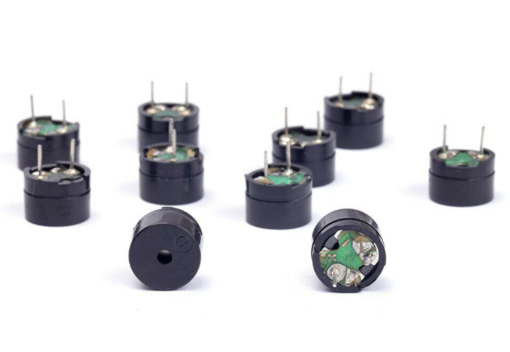

A passive buzzer is an integrated electronic buzzer with no internal vibration source. It must be driven by 2K to 5K square wave, not a DC signal. The two buzzers are very similar in appearance, but one buzzer with a green circuit board is a passive buzzer, while the other with black tape is an active buzzer. Passive buzzers cannot distinguish between positive polarity while active buzzers can.

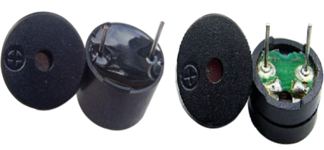

1. **Circuit Diagram and Wiring Diagram**

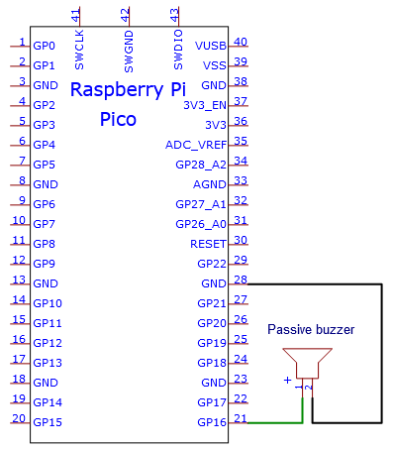

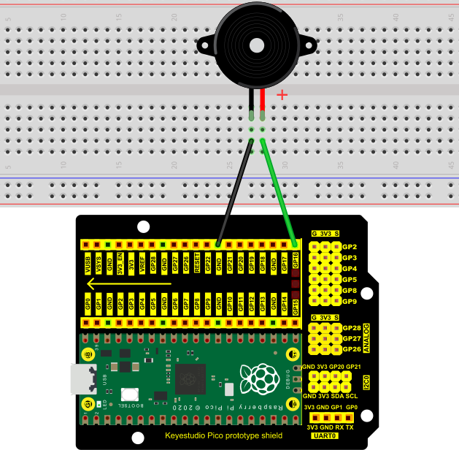

**4. Test Code：**

You can open the code we provide:

Go to the folder KS3020 Keyestudio Raspberry Pi Pico Learning Kit Ultimate Edition\2. Windows System\2. C\_Tutorial\2. Projects\Project 13：Passive Buzzer\Project\_13\_Passive\_Buzzer.

|  |
| --- |
| //\*\*\*\*\*\*\*\*\*\*\*\*\*\*\*\*\*\*\*\*\*\*\*\*\*\*\*\*\*\*\*\*\*\*\*\*\*\*\*\*\*\*\*\*\*\*\*\*\*\*\*\*\*\*\*\*\*\*\*\*\*\*\*\*\*\*\*\*\*\*  /\*  \* Filename : Passive Buzzer  \* Description : Passive Buzzer sounds the alarm.  \* Auther : http//www.keyestudio.com  \*/  #define PIN\_BUZZER 16 //define buzzer pins  void setup() {  pinMode(PIN\_BUZZER, OUTPUT);  }  void loop() {  alert();  }  void alert() {  float sinVal; // Define a variable to save sine value  int toneVal; // Define a variable to save sound frequency  for (int x = 0; x < 360; x += 10) { // X from 0 degree->360 degree  sinVal = sin(x \* (PI / 180)); // Calculate the sine of x  toneVal = 2000 + sinVal \* 500; // Calculate sound frequency according to the sine of x  freq(PIN\_BUZZER, toneVal, 10);  }  }  void freq(int PIN, int freqs, int times) {  if (freqs == 0) {  digitalWrite(PIN, LOW);  }  else {  for (int i = 0; i < times \* freqs / 1000; i ++) {  digitalWrite(PIN, HIGH);  delayMicroseconds(1000000 / freqs / 2);  digitalWrite(PIN, LOW);  delayMicroseconds(1000000 / freqs / 2);  }  }  }  //\*\*\*\*\*\*\*\*\*\*\*\*\*\*\*\*\*\*\*\*\*\*\*\*\*\*\*\*\*\*\*\*\*\*\*\*\*\*\*\*\*\*\*\*\*\*\*\*\*\*\*\*\*\*\*\*\*\*\*\*\*\*\*\*\*\*\*\*\*\* |

Before uploading Test Code to Raspberry Pi Pico, please check the configuration of Arduino IDE.

Click "Tools" to confirm that the board type and ports.

**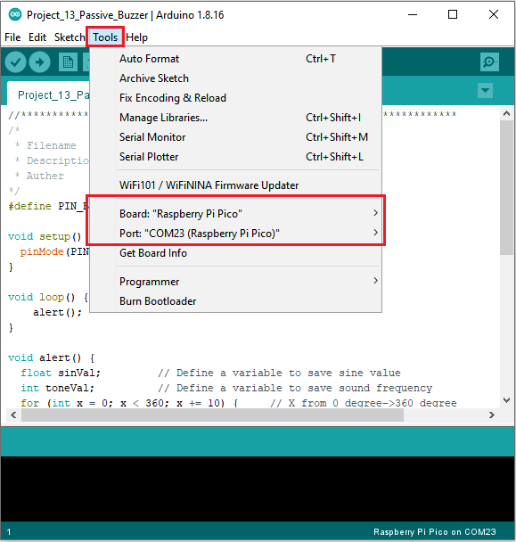**

Click  to upload the test code to the Raspberry Pi Pico board

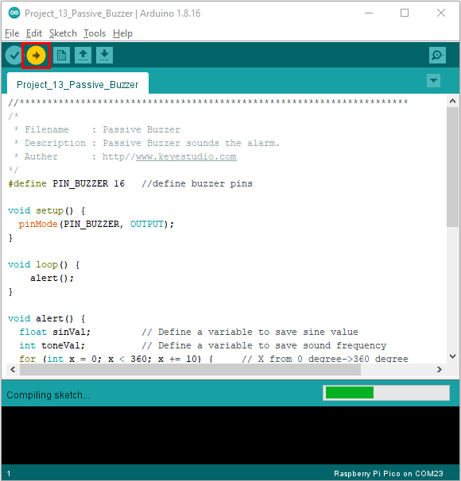

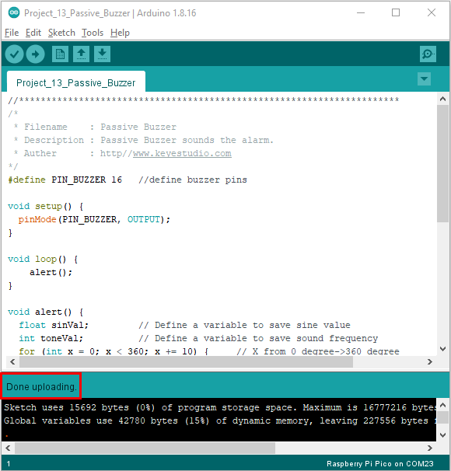

1. **Result**

Upload the project code, wire up and power on, then the passive buzzer will alarm